Role: Team Leader and Front-End Developer

Kaelan Reece N8880778

Personal Portfolio

IFB 299 Application Design & Development

# Release One

## Artefact One

### **Homepage**

The homepage is a very important part of the application as it is the first thing users see when they visit a webpage. I therefore followed a traditional website layout with the logo, header, content and footer being displayed neatly and in order, ensuring the application was both familiar and easy to navigate. The homepage itself features scrolling images and a short description of the image, which makes it more visually appealing to users. This artefact contributes significantly to this release as it forms the main portal by which the entire website is accessed and was therefore designed to be easy to use and attractive for users.

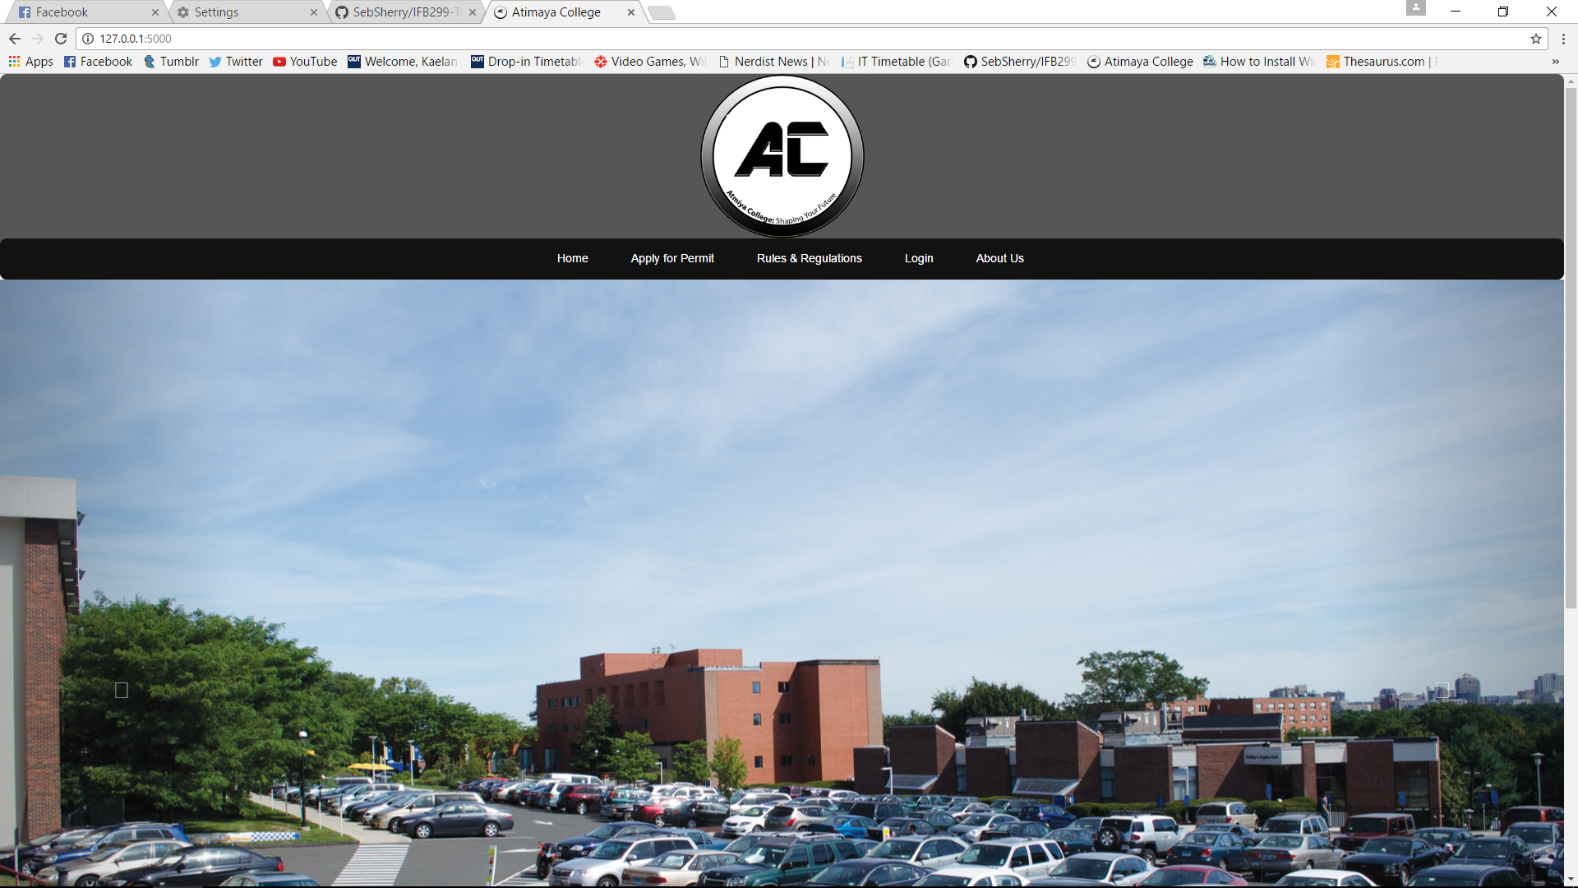

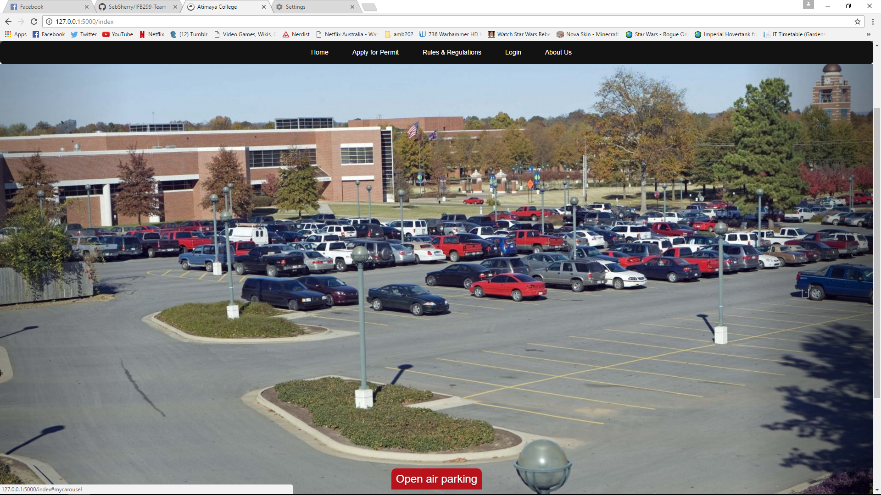

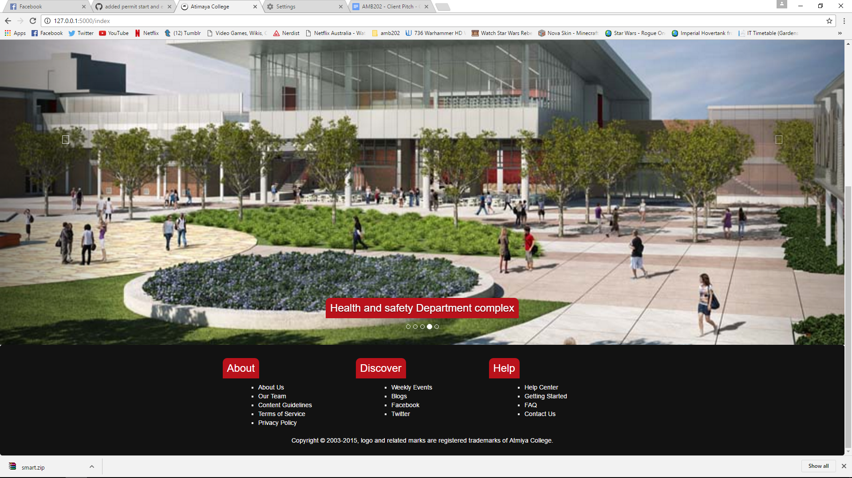

## Artefact Two

### **Application Page**

The application page formed an integral part of the system as it allowed admins to submit different types of violations. There were several different types of violations which could be submitted; parking, smoking or other violations. Recognizing that it would be overly complicated to have a different submission form for each violation, I made a form which builds itself based on the type of violation. This gave admins an easy to use reporting system which streamlined the entire citation system.

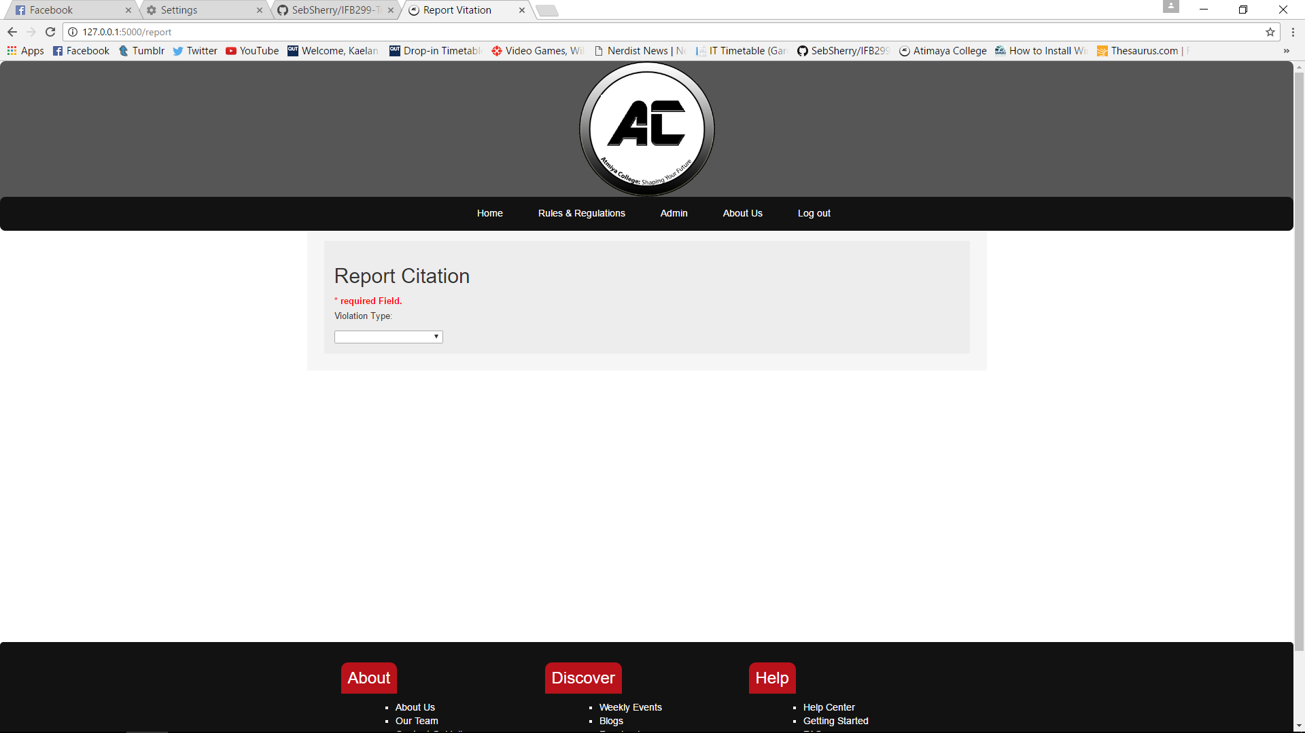

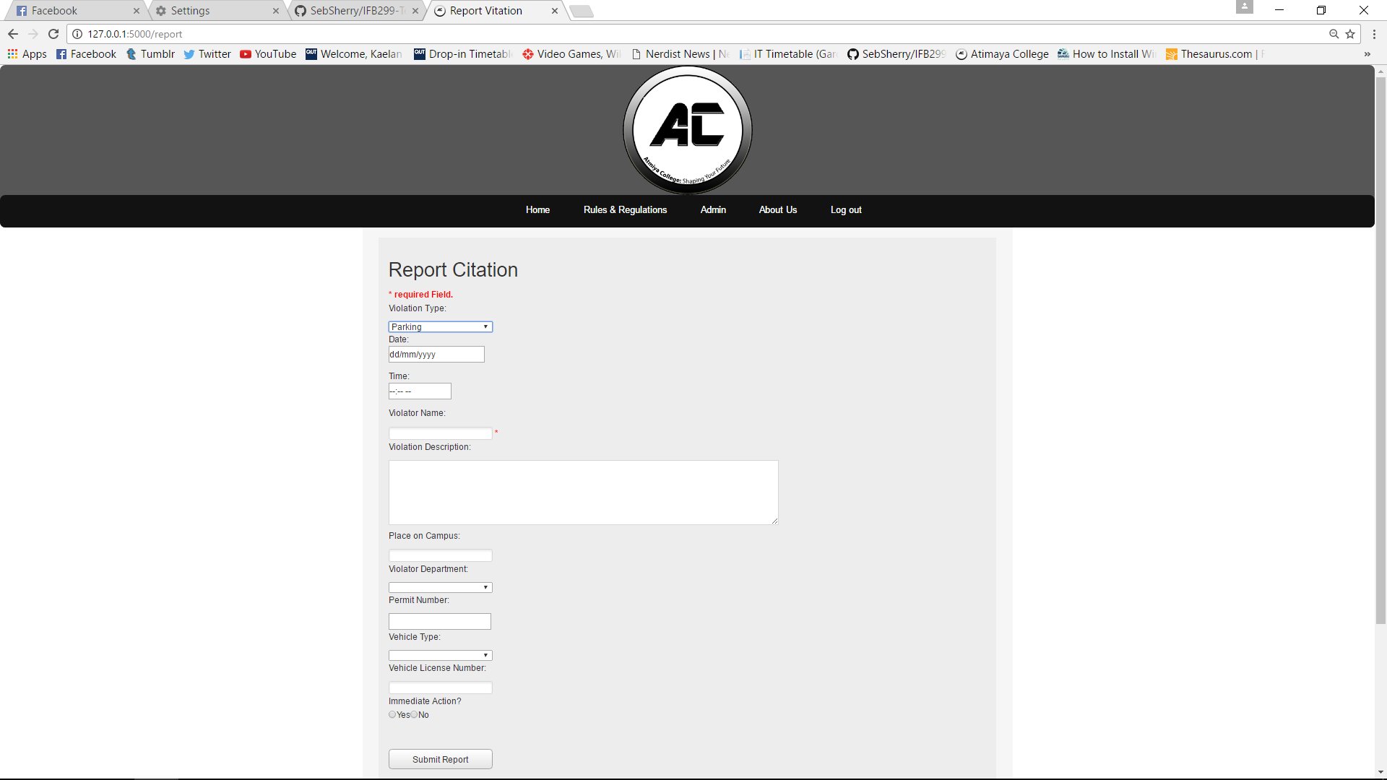

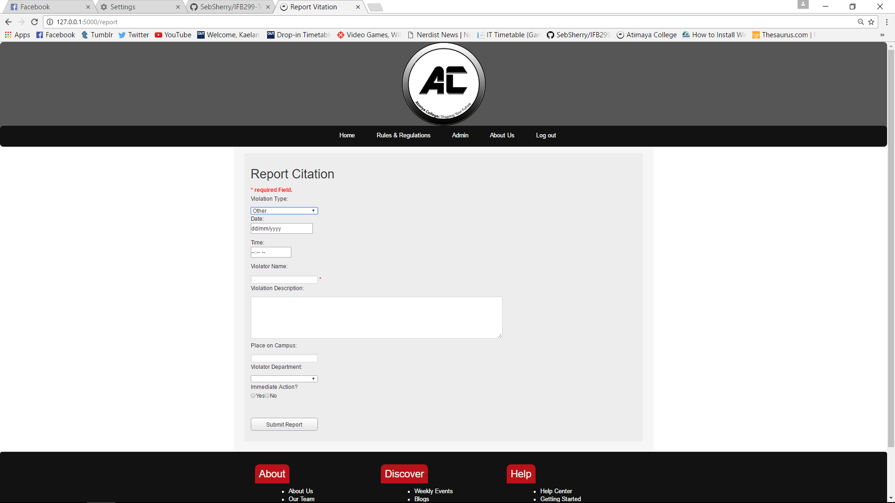

## Artefact Three

### **Webpage Content**

The original specifications were limited on the level of content needed for the project, I therefore had to conduct substantial research into existing parking and violations systems to gain a comprehensive understanding of what was required. While not directly contributing to the functionality of the application itself, this content gave our team a basis to form our system around and provided significant value to users. This artefact contributed to laying the foundation, contextualising the website and giving it purpose.

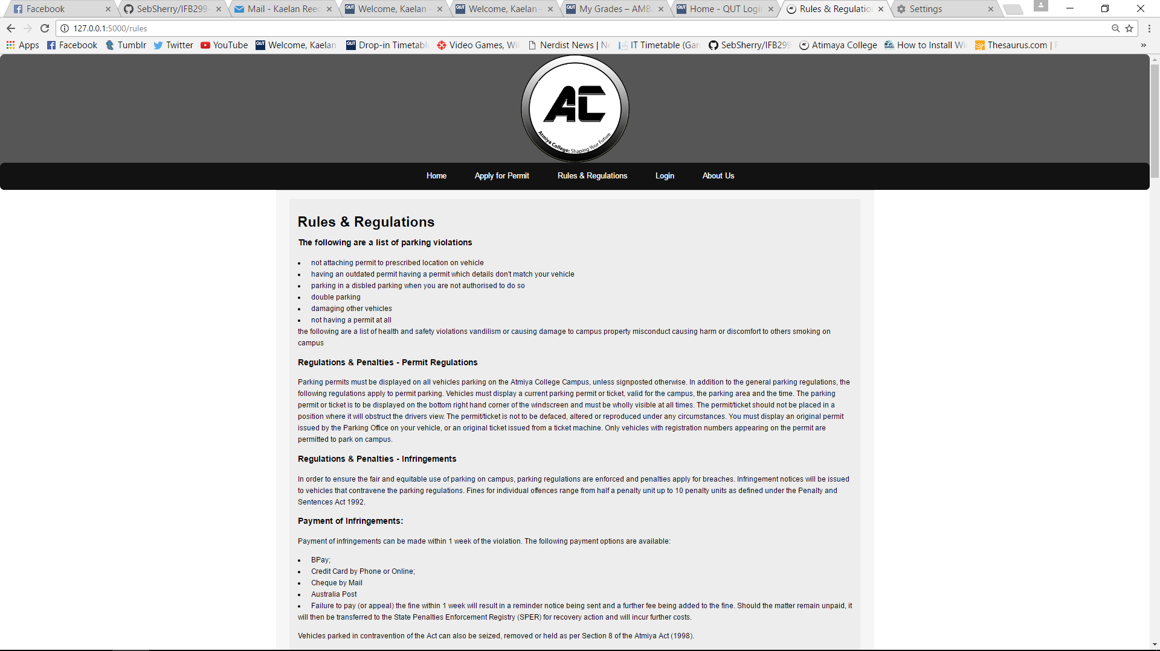

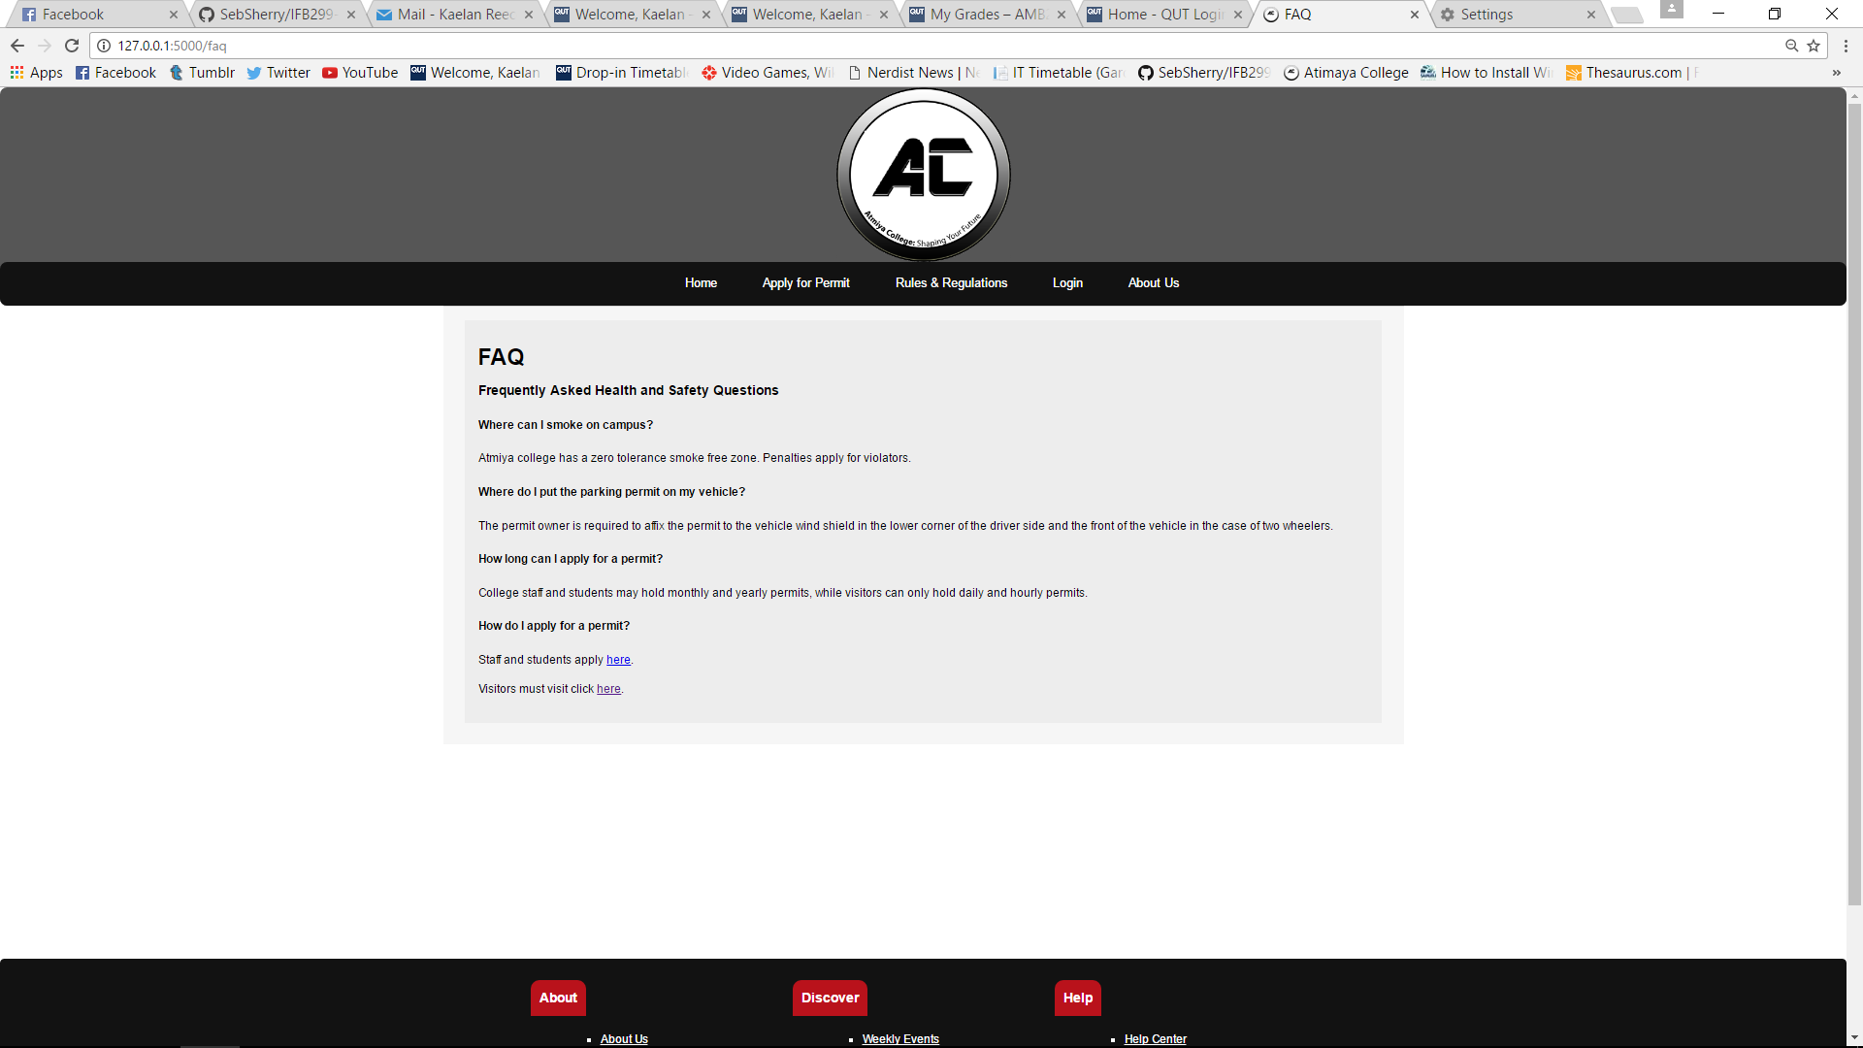

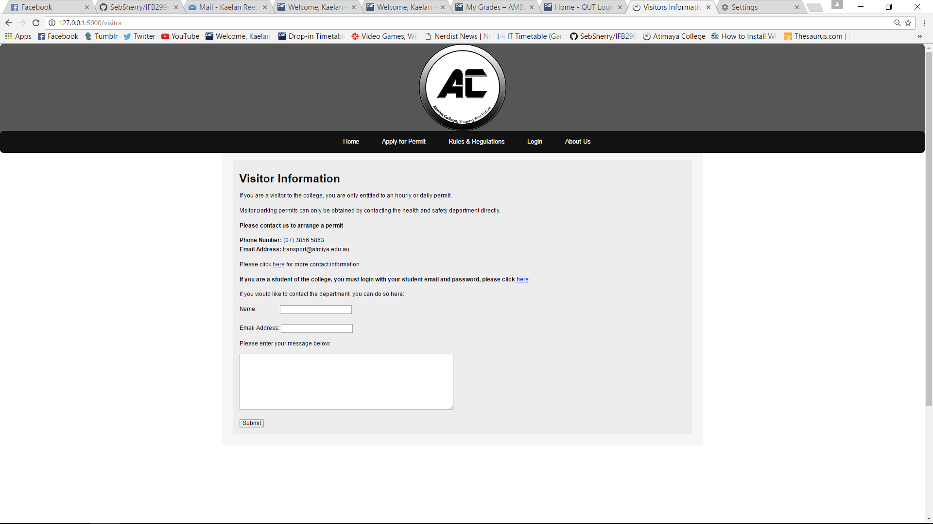

## Artefact Four

### **Include Files and Code Cleaning**

Throughout this release I contributed heavily towards providing my team with additional resources and made coding significantly easier for them. Using skills, I learned from previous units, I added include files for both the header and the footer for each page so that any changes were seamlessly deployed across the website, as well as creating an orderly design. I included JQuery, Bootstrap and several external styling sheets to support both the front end and back end design of the application, providing the rest of the team with more advanced tools to complete their tasks. I commented and cleaned code throughout this release so that my team members could readily add their functions to the website without causing any conflicts.

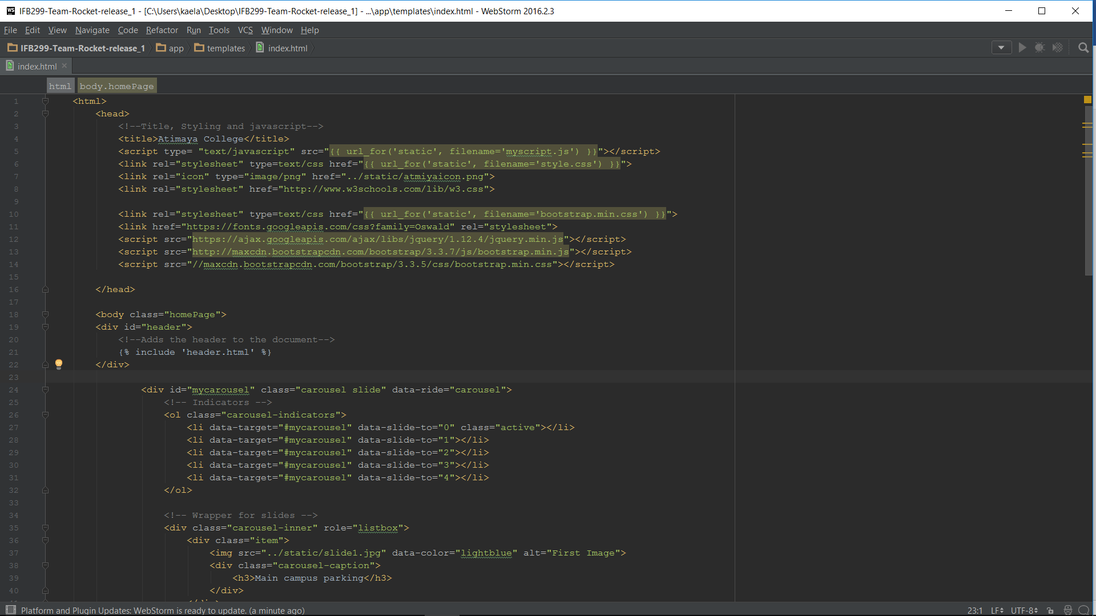

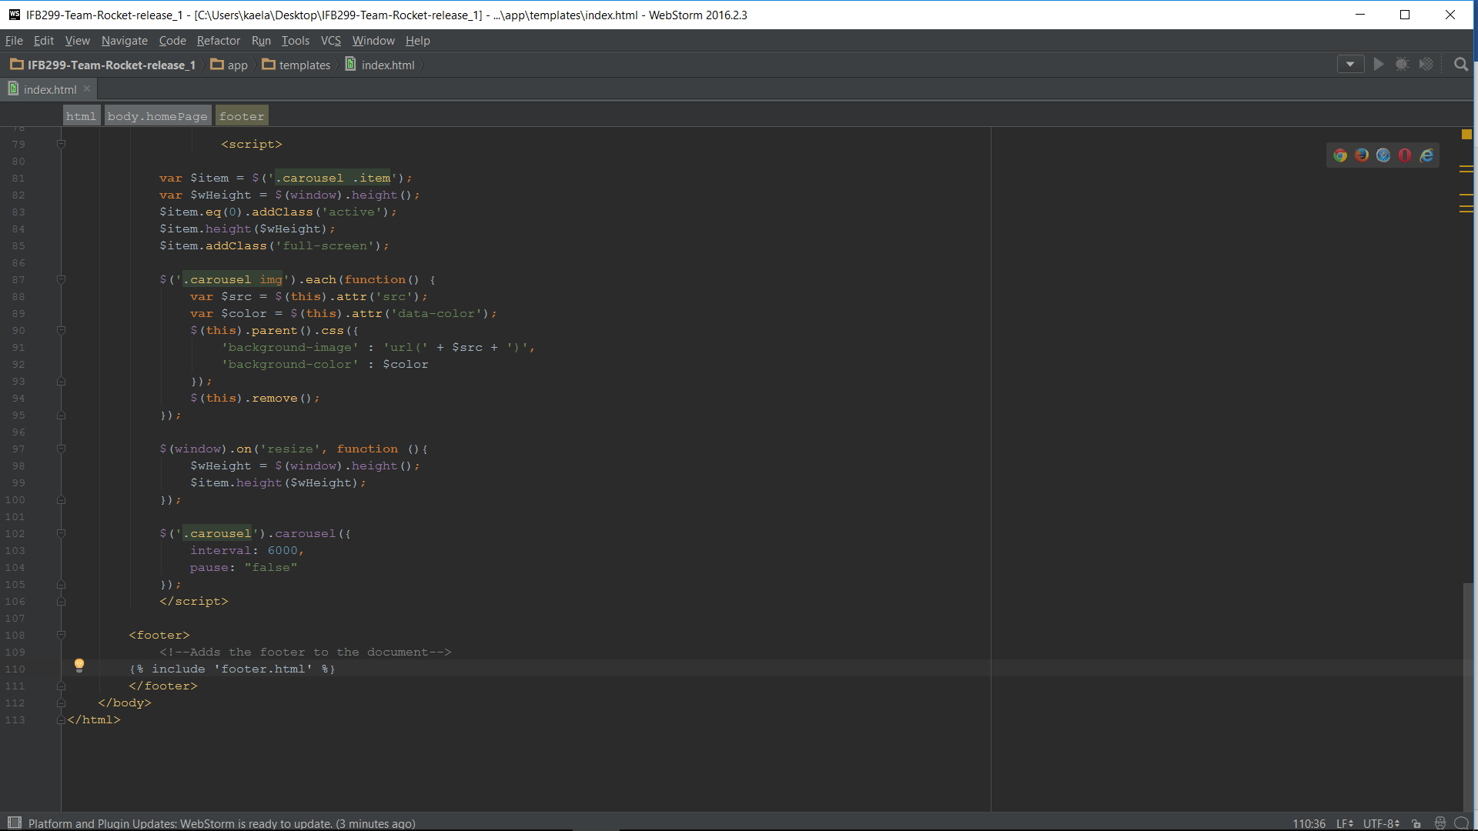

## Artefact Five

**Application Form and basic form checking**

Perhaps the most integral part of our application was that users had the ability to apply for a permit, the system itself managed their permit application. I created the permit application form and added a basic form checking function which could be applied to any future forms. This would guarantee that all required fields were entered and supplied user with an explanation for why the application was not processed.

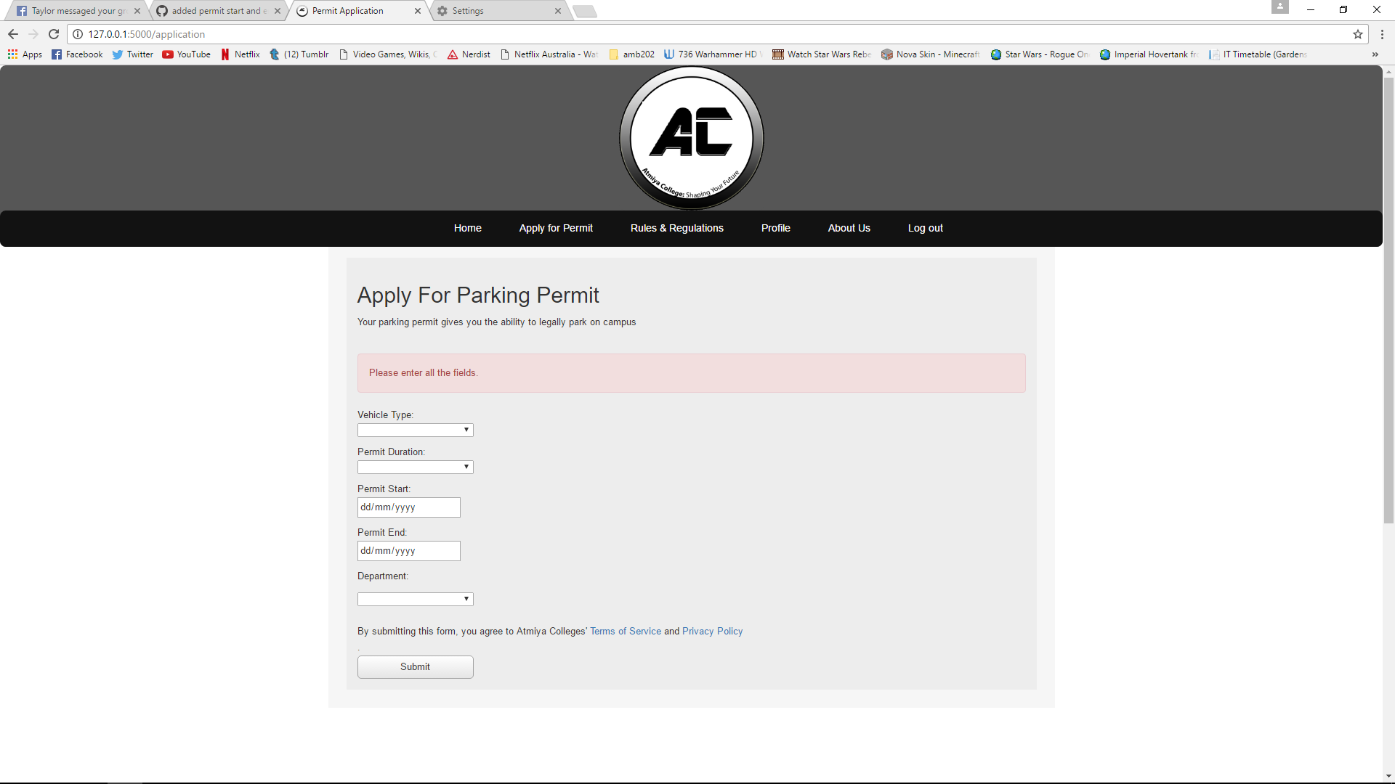  
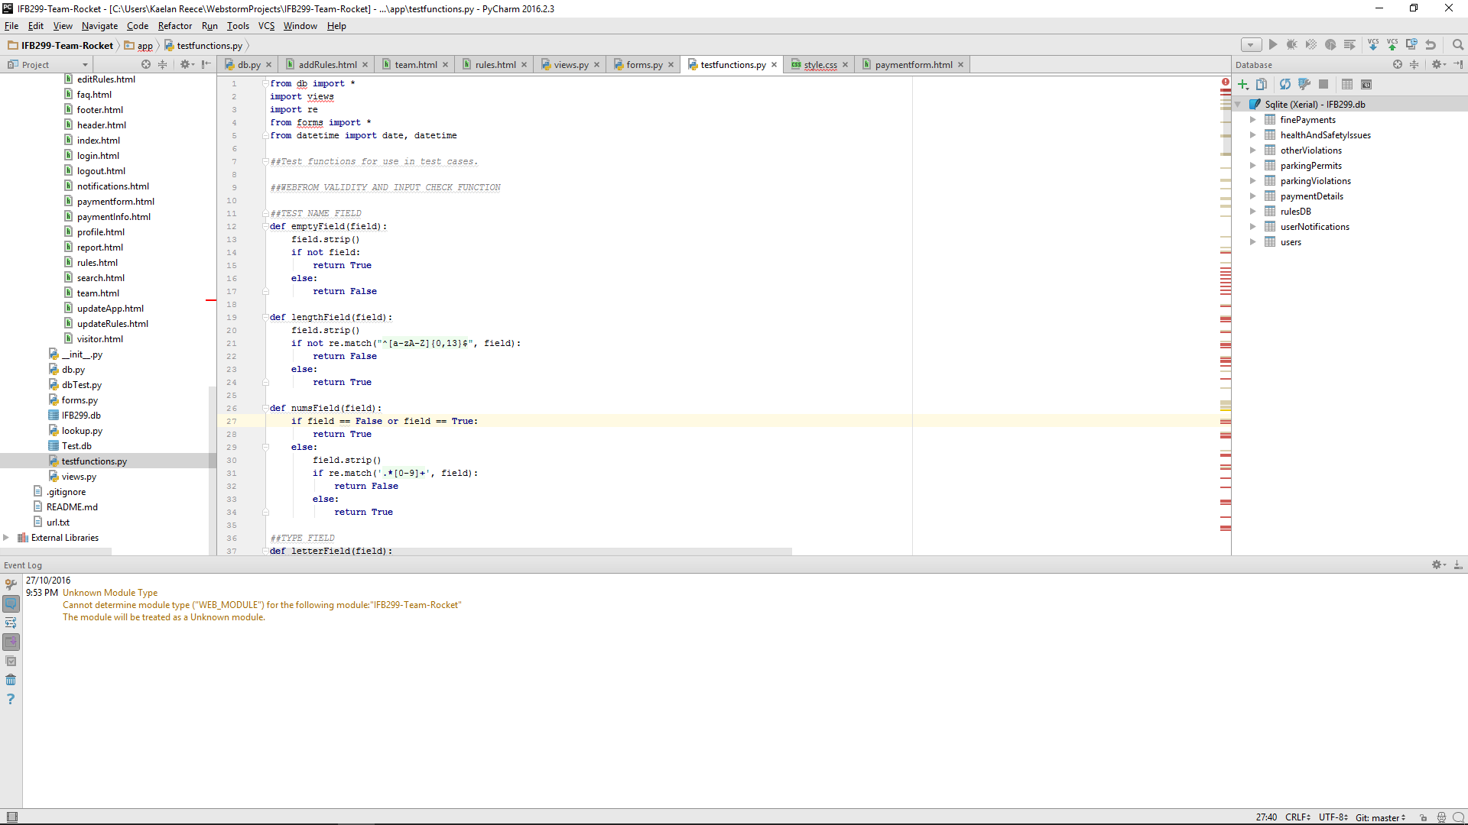

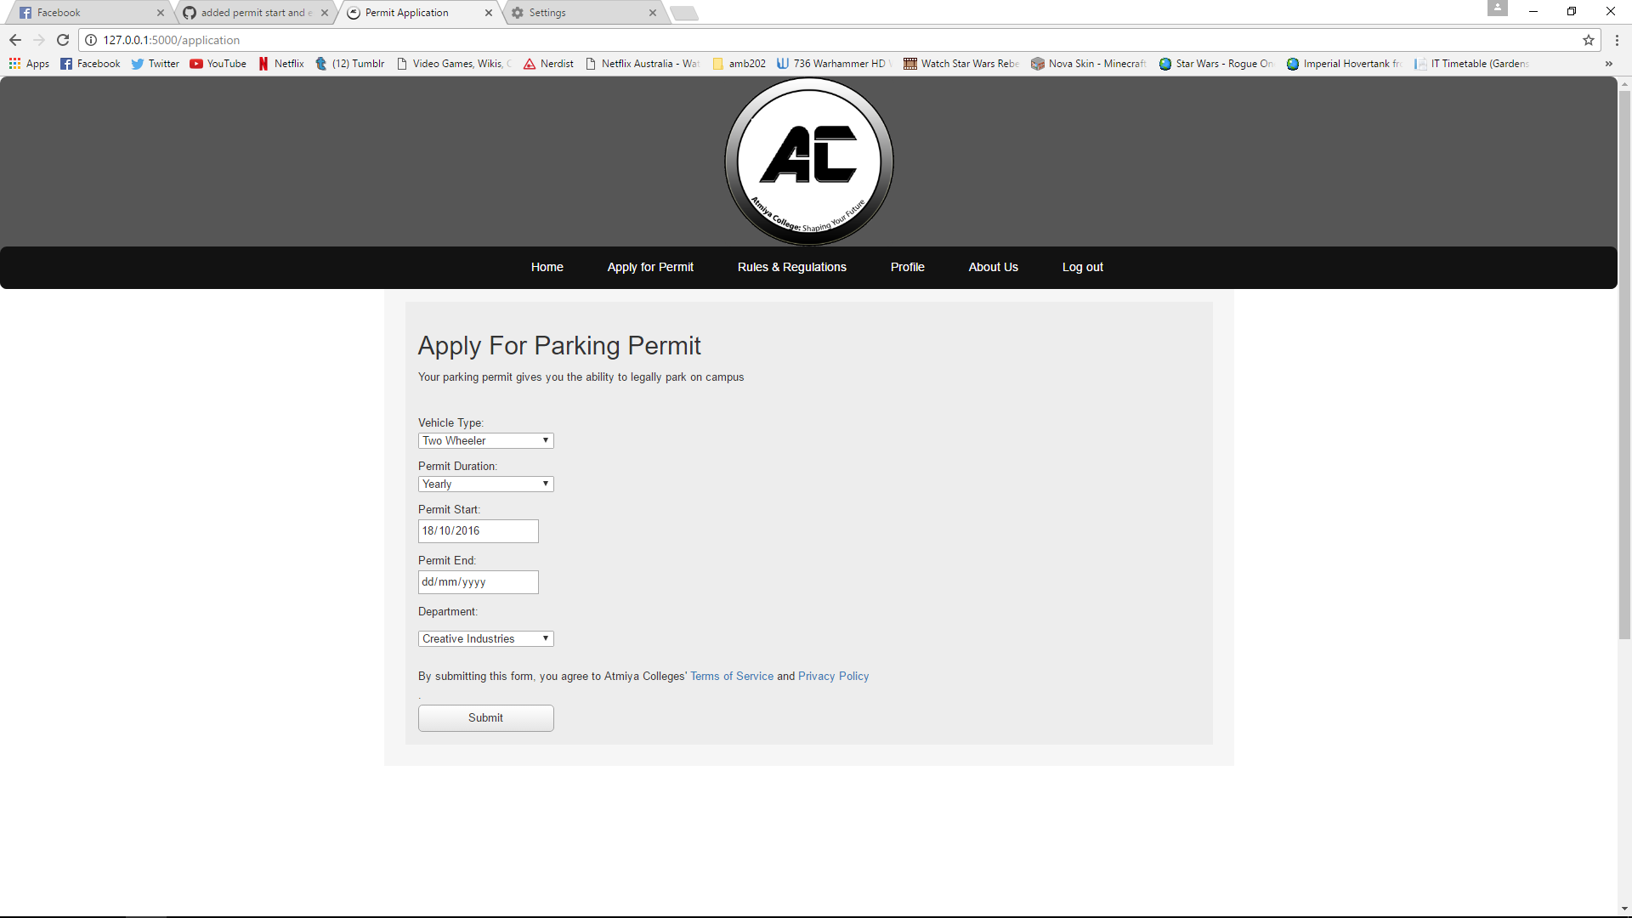

**Release Two**

## Story Updates and Notifications Changes

During this release, I contributed to updating the user stories and application in accordance with the client’s feedback and provided an explanation for each change. The most significant change to the user stories were that ‘emergency updates’ were completely overhauled to become ‘generic updates’ and a ‘must have’ user story. This change was significant as the system would notify users of the day to day operations on campus, which were far less severe than the previous notification types in terms of what they mean to the user and how they were notified of these updates. I therefore updated the story card, documentation and the application itself to reflect these changes.

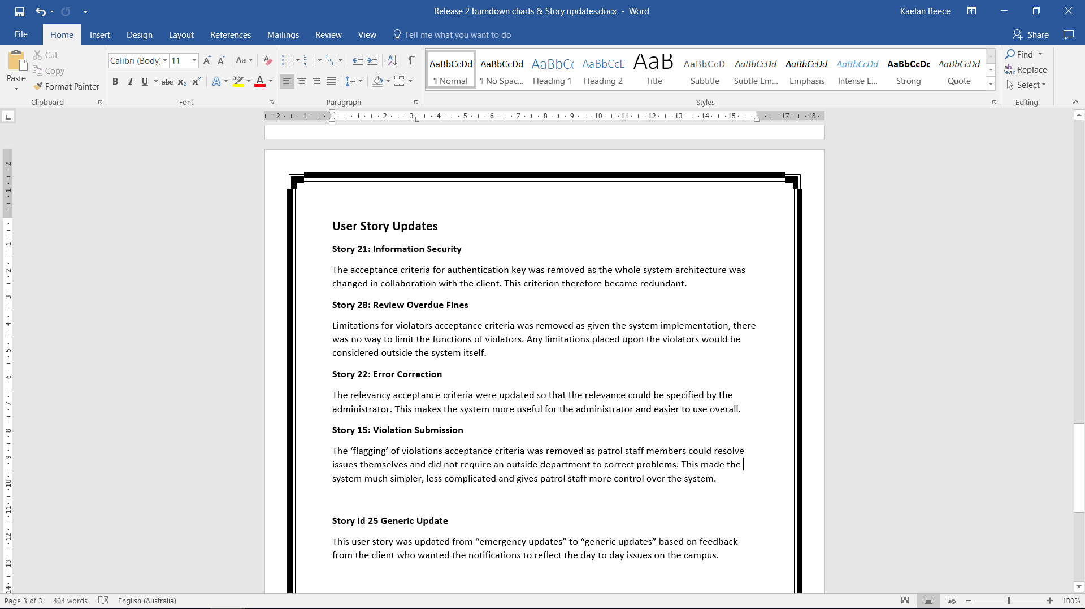

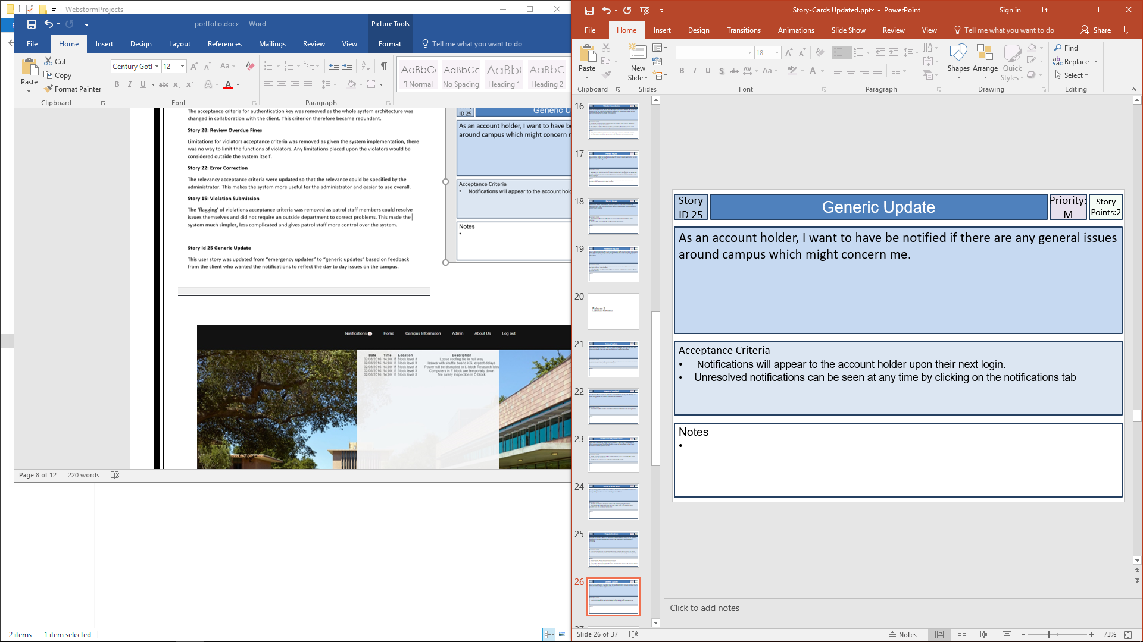

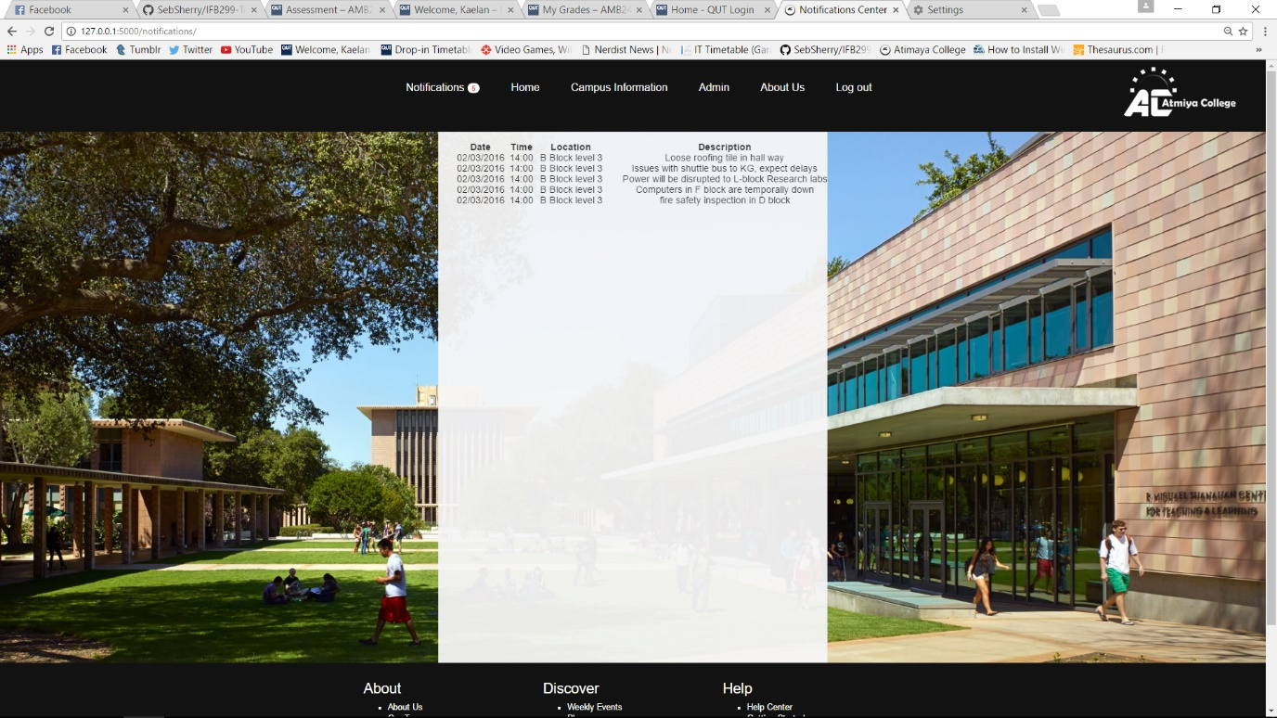

## Artefact two

### **Website and Content Design**

While this artefact added no direct functionality, I contributed significantly to updating the website design for this release. This involved adding a distinct background for various pages and adding opacity to the content boxes. The site was therefore more visually appealing and immediately draws the eye to the centre of the page, making the content easier to read. Some of these changes were based on the client, tutor and peer feedback, the removal of whitespace drastically improved the look and feel of these pages. The other changes I made to website design focused on removing duplicated content and making information easier to find as well as tweaking existing colour schemes. In this regard, I completely reorganised the original rules page and added an infringements and payments page to separate the content based on user needs.

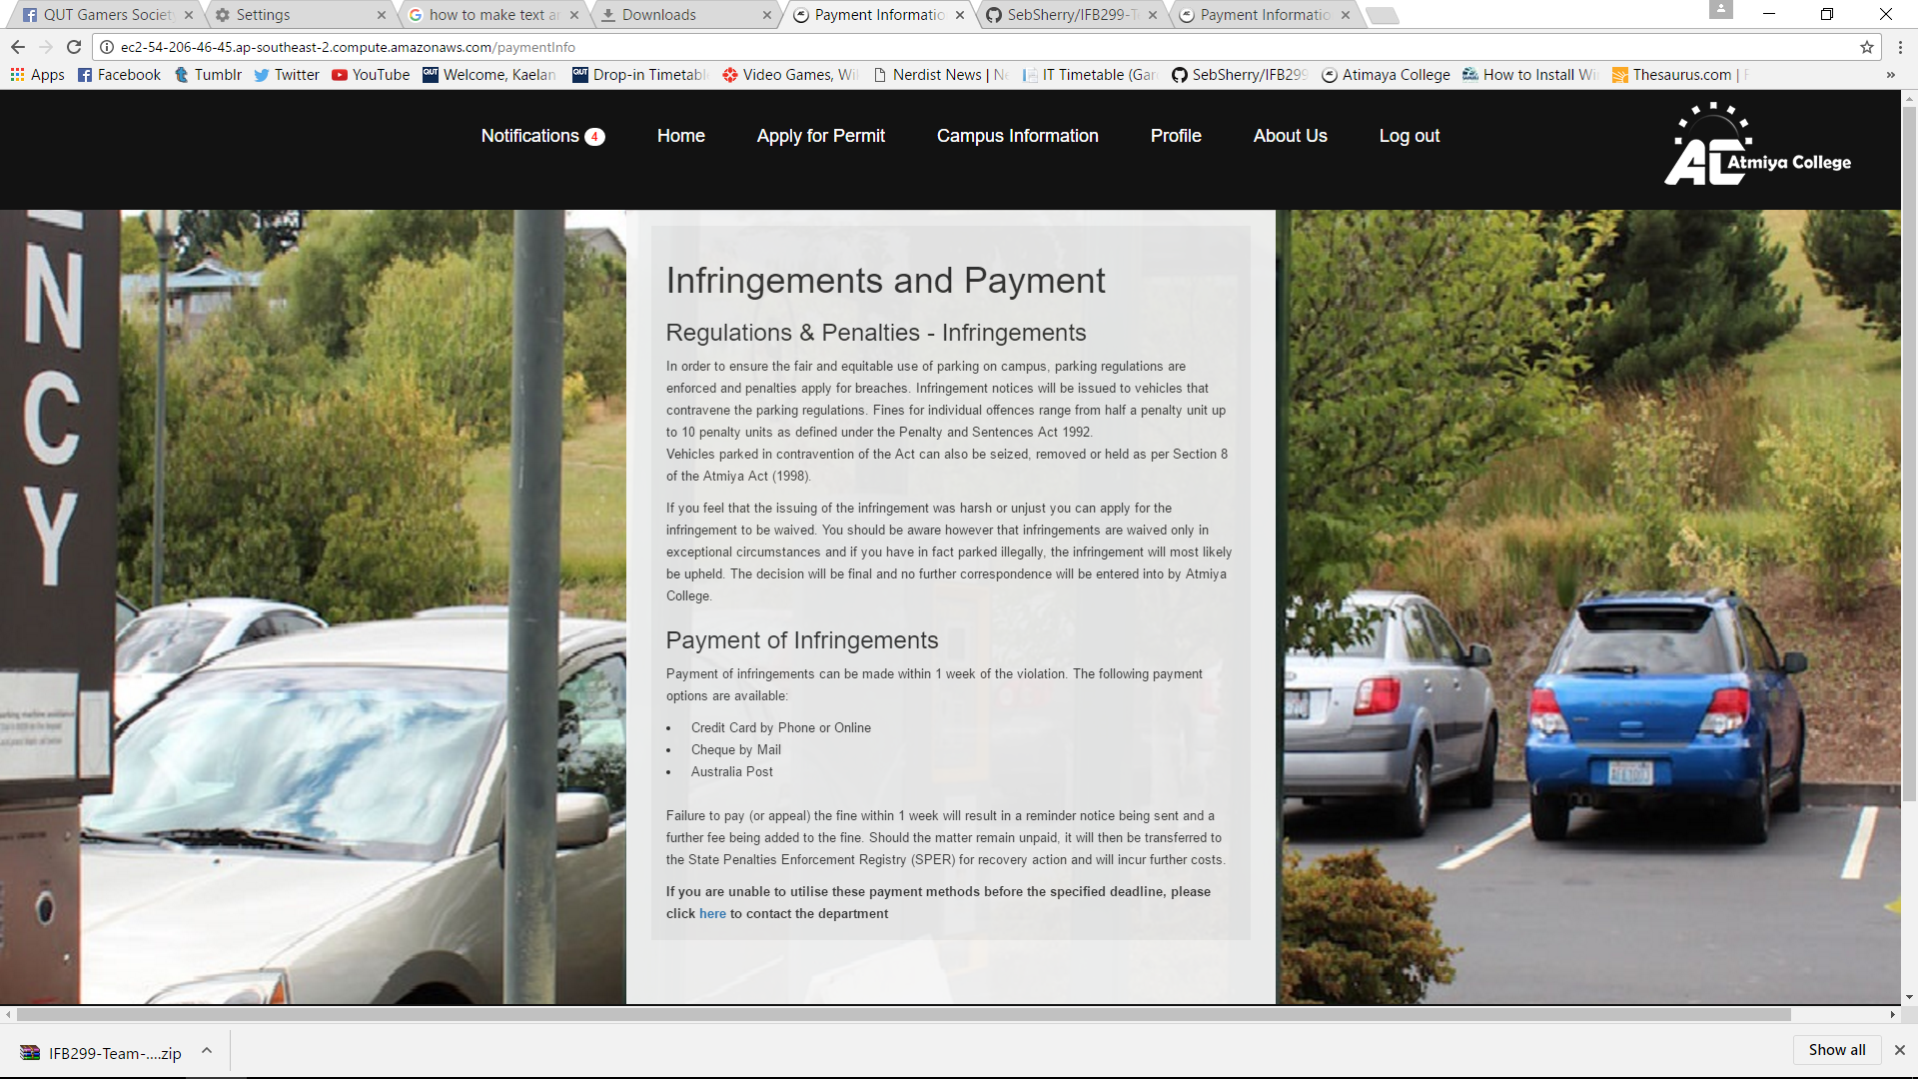

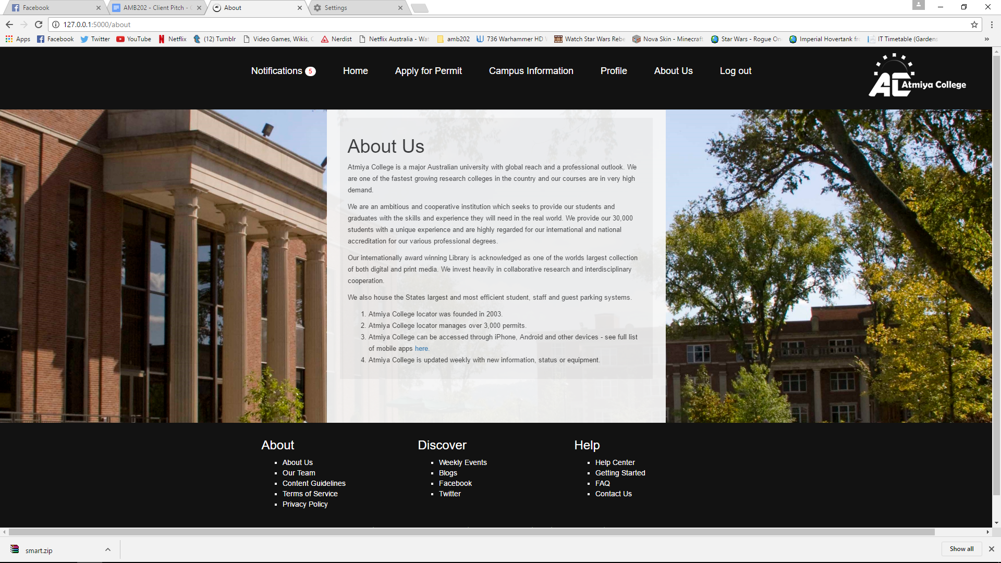

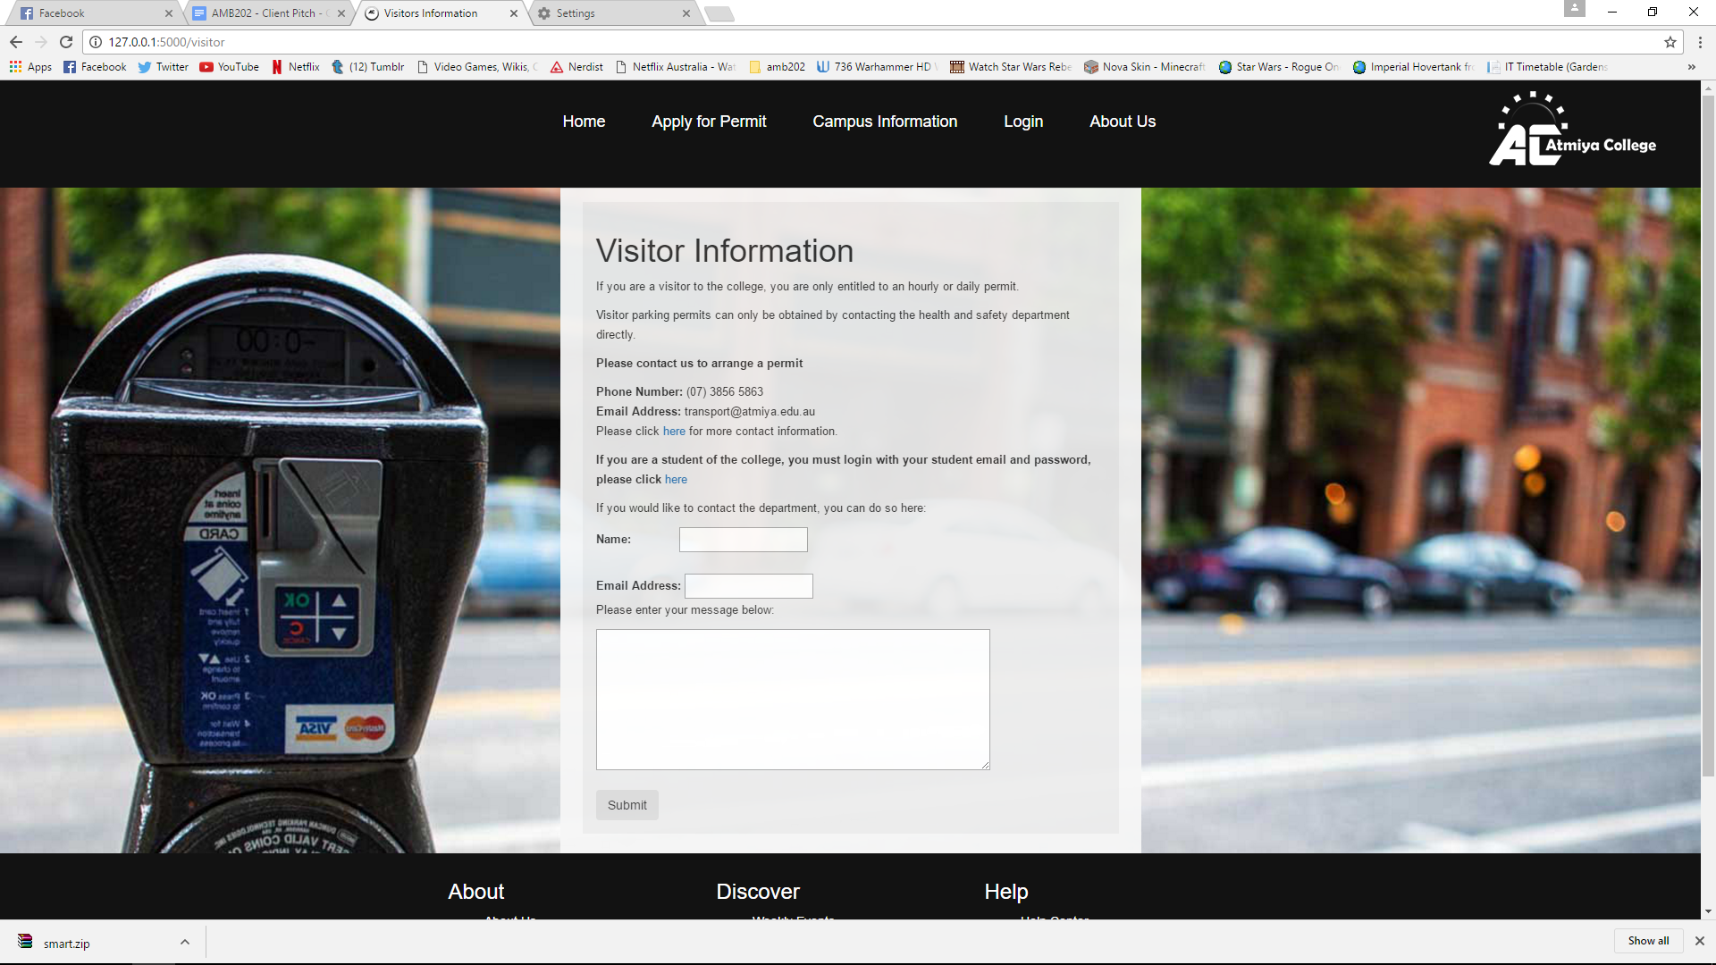

## Artefact three

### **Header and Logo Updates**

One of the largest contributions to the second release was to redesign the header and logo for the web application. This was very important because the navigation bar is used to traverse the entire website and should therefore be clean and easy to use. The original logo was too big, hard to read and created a significant amount of empty.

**Original Header and Logo**



The updated Header, which is seen below is a much cleaner design which not only adds additional dropdown menu’s but has the logo sitting comfortably within the navigation bar itself. This removed the whitespace problem and the new logo was much easier to read, sleaker and better reflected a logo for a liscensed college. The previous logo on the other hand was very basic and more of a badge than a logo. This badge was therefore effectively repurposed as a distinct icon which made the site easier to find for users navigating through multiple tags.

**Updated Header**

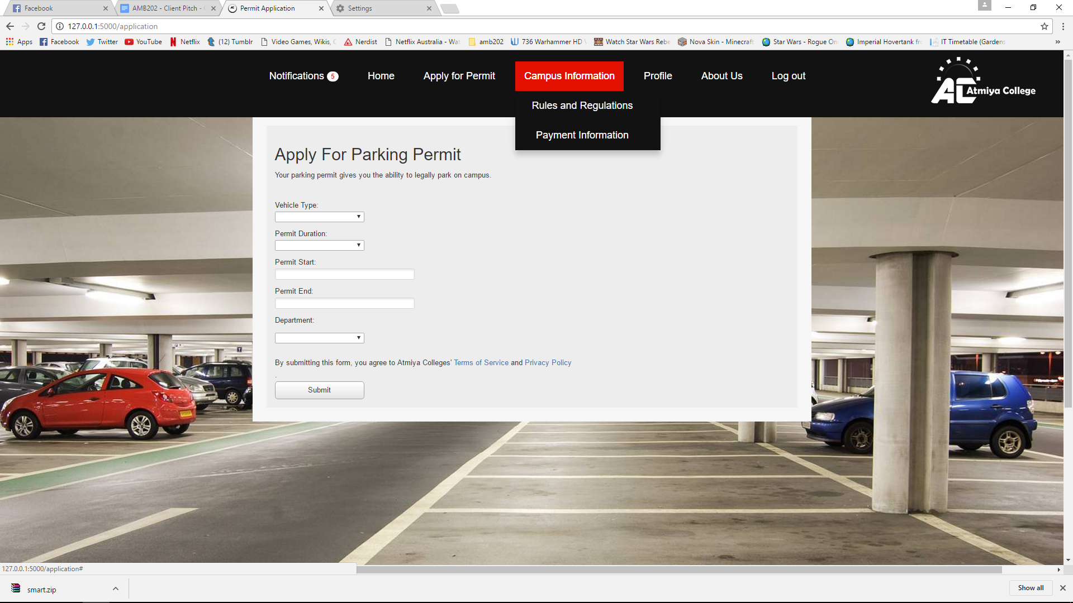

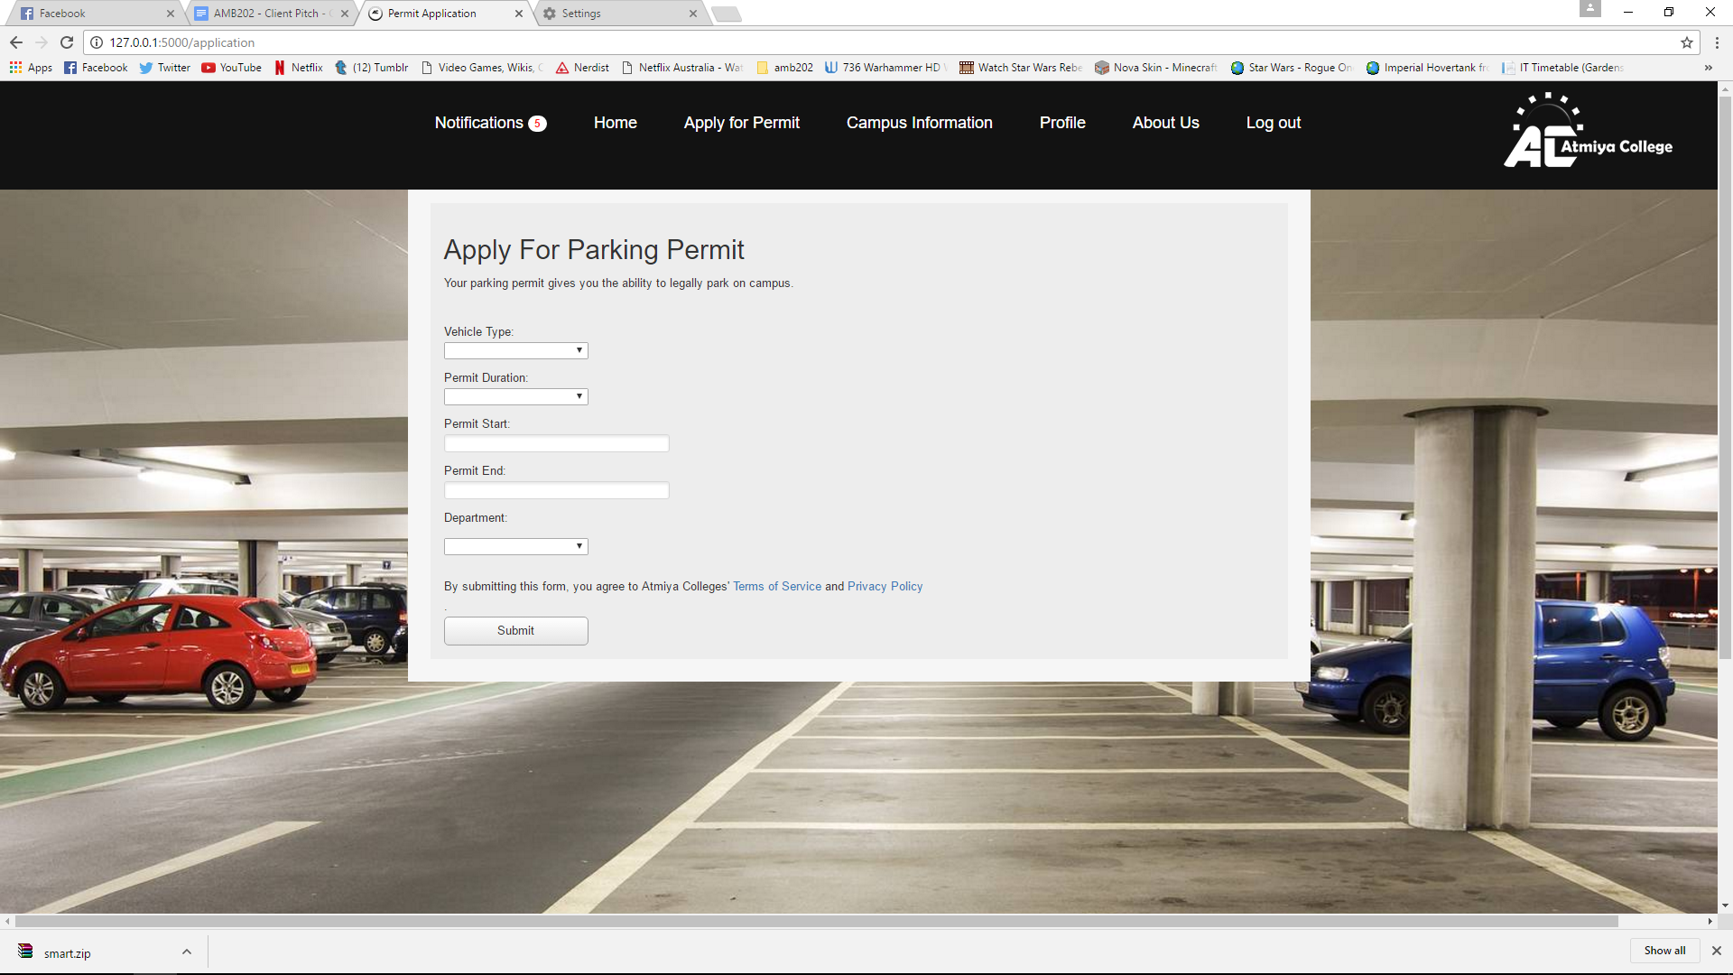

## Artefact Four

### **Payment Form**

I contributed the payment form during this release which is the front-end implementation of the violation resolution. From here the user can pay parking, smoking or other violations. This was a very important part of the application as it now gives users a gateway to resolve issues, it was therefore crucial that they could enter in all the required information to pay the fine. Otherwise they would be penalised if they were unable to pay overdue fines. I worked on the front-end form styling, layout and form which were designed to support the back-end implementation of this feature. I used several existing payment and checkout pages from official websites such as steam and eBay to design this form. This proved to be a very efficient way to account for everything required to deploy this feature into the application.

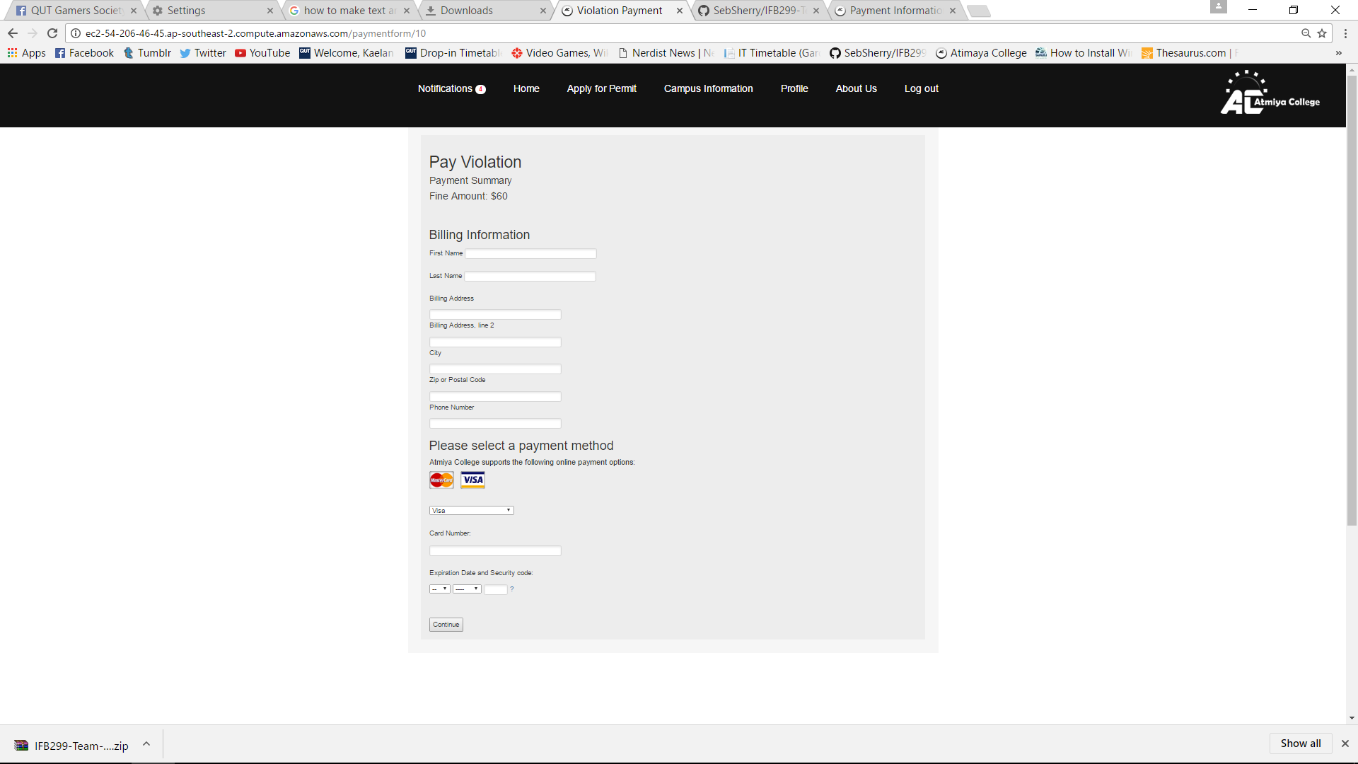

## Artefact Five

### **Database Rule Control**

An essential feature to support Administrators was having the ability to add, update and delete rules from the database. While previously stored in plain text and taking up significant space, I completely overhauled the rules and added dynamically generated expansion bars to make it neater and so users could easily find a rule and learn more about it. While previously stored as static html text, I redesigned the rules as database entries, updated styling and added code. This allowed new rules to be added and existing rules to be deleted. I even included a confirmation box to reduce the chance rules were accidentally deleted and made it even more convenient for administrators to operate. This feature provided significant control over the database and supported Oliver’s task of updating existing rules and deploying notifications for when new rules were added or existing rules were updated.

